Add edit and delete Location

When you sign up for Apple Business Manager, the first location is automatically created (called the primary location) and reflects your organization name. As you expand your use to other locations or offices, you can add more locations and edit their information. Additional locations can mirror physical locations or organizational units. Apps and Books can then be provisioned to specific locations. User roles such as Content Manager and Staff can be assigned to locations.

There are two roles that have privileges for managing locations: Administrator (the role with the most privileges) and People Manager (which has the next largest set of privileges after Administrator).

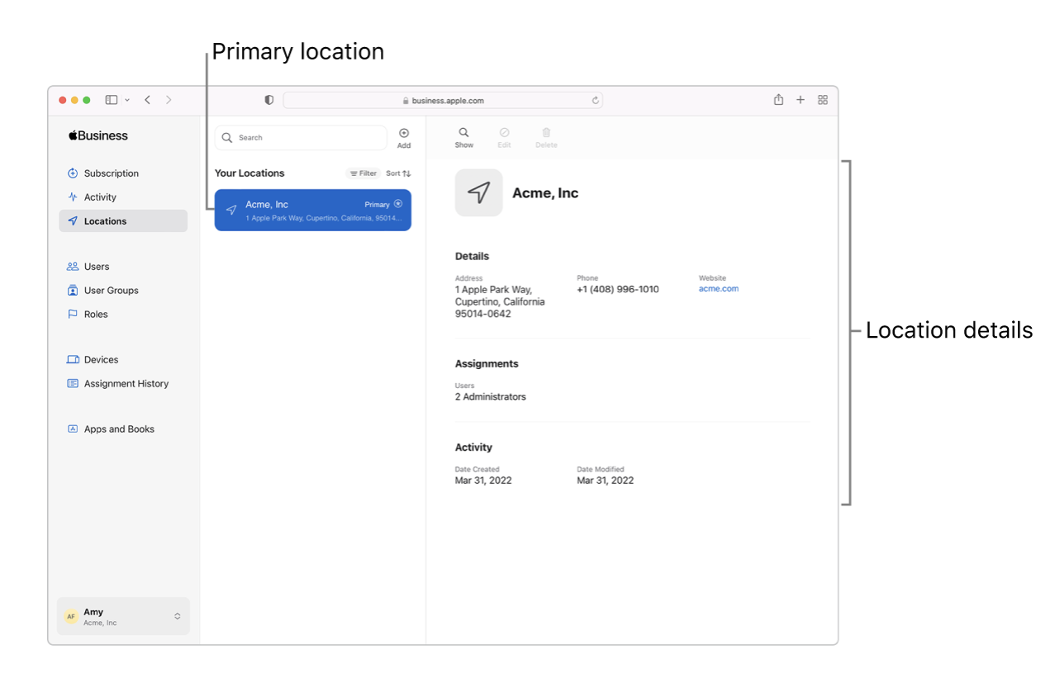

Add and verify a domainFQDN (Fully Qualified Domain Name) in the Apple Business Manager

The reason you add and verify a domain is to take advantage of Managed Apple Accounts. These accounts—similar to personal Apple Accounts—use an email address as the account name to sign in to websites, apps, and more. The Managed Apple Account name (the email address) must be globally unique. If you didn’t register a domain, you can use the reserved domain.

Reserved domains
A reserved domain is automatically created for any Apple Business Manager organization. The reserved domain can be used if no custom domain is available. It has the following properties:
- It’s based on the website entered during the sign-up process.
- It doesn’t require the organization to verify the domain.
- It can’t be edited or removed.
For example, if you enrolled using the website www.betterbag.com, the reserved domain name would be betterbag.appleaccount.com. If multiple organizations use the same domain, an incremental number is added to the name, such as betterbag2.appleaccount.com.

Requirements for automatically adding devices
The following conditions must be met to automatically add devices to Apple Business Essentials:
- If the device was purchased directly from Apple, the purchaser must have used an enrolled and verified Apple Customer Number.
- If the device was purchased directly from a participating Apple Authorized Reseller or an authorized cellular carrier, the device must be linked to that reseller’s Reseller Number. The actual date of eligibility is determined by the participating Apple Authorized Reseller or authorized cellular carrier sales history. The Reseller Number must be added to your organization’s list of approved suppliers.
- The device must have been ordered after March 1, 2011, whether it was purchased directly from Apple, from a participating Apple Authorized Reseller, or an authorized cellular carrier.

Use Managed Apple Accounts in Apple Business Manager

Managed Apple Accounts are designed to increase the productivity of employees and provide the services users may need

Unlike personal Apple Accounts, Managed Apple Accounts are owned and managed by an organisation — including password resets and role-based administration. They also provide access to iCloud for collaboration with iWork and Notes — and backup on iPhone and iPad devices. Apple Business Manager makes it easy for organisations to create and manage these accounts at scale.

Important: A user with a Managed Apple Account can be locked out of their account if they enter an incorrect password more than 10 times or if Apple suspects any fraudulent activity on their account. To reset their password, the user must contact any user with the role of Administrator or People Manager. For users locked due to suspected fraudulent activities, an Apple Business Manager user with the role of Administrator must contact Apple to have the account unlocked. At that point, the user’s password can be reset by a user with the role of Administrator.

How Managed Apple Accounts are created
Managed Apple Accounts are created after you:
- Configure and enable federated authentication with Google Workspace, Microsoft Entra ID or your identity provider (IdP)
See Introduction to federated authentication.
Note: If your organisation is using federated authentication, the Default Managed Apple Account Format setting does not apply.
- sync with Google Workspace
See Sync user accounts from Google Workspace.
- Sync using Open ID Connect (OIDC) with Microsoft Entra ID
See Sync user accounts from Microsoft Entra ID.
- Sync using Open ID Connect (OIDC) or System for Cross-domain Identity Management (SCIM) with your IdP
See Sync users from your identity provider.
Important: Keep in mind that every Managed Apple Account must be unique. It also cannot be the same as other Apple Accounts that other users may already have.

Customise user access to certain apps and services using Apple Business Manager
You may want users who sign in with a Managed Apple Account to access many Apple apps and services. With Apple Business Manager, you can choose what devices users can sign in to and which apps and services are available to them. For example, you can turn on access to specific iCloud features, specify which app data they can store in the cloud, and turn off access to FaceTime and iMessage.

Service access with Managed Apple Accounts

https://support.apple.com/en-in/guide/deployment/depdc4ba8d82/web

Manage iCloud features and app access

Turn on user access to Apple Developer content

Manage iCloud access

Use iMessage and FaceTime in Apple deployments

FaceTime
FaceTime is the Apple video and audio calling service. FaceTime calls use the APNs to establish a connection and then uses two protocols — the Internet Connectivity Establishment protocol and the Session Initiation Protocol — to create an encrypted stream. Users can communicate between any mix of supported Apple devices using FaceTime.
Note: FaceTime and iMessage may not be available in all countries or regions.

Manage Setup Assistant for Apple devices

Passkey and hardware security key support during enrolment
For a Mac with macOS 15 or later, Setup Assistant supports ASWebAuthenticationSession, allowing support for passkeys and supported hardware security keys during enrolment.

Set-up Assistant pane options

Set up local macOS accounts

Sync user accounts from Microsoft Entra ID to Apple Business Manager

You can use OpenID Connect (OIDC) to sync user accounts to Apple Business Manager.

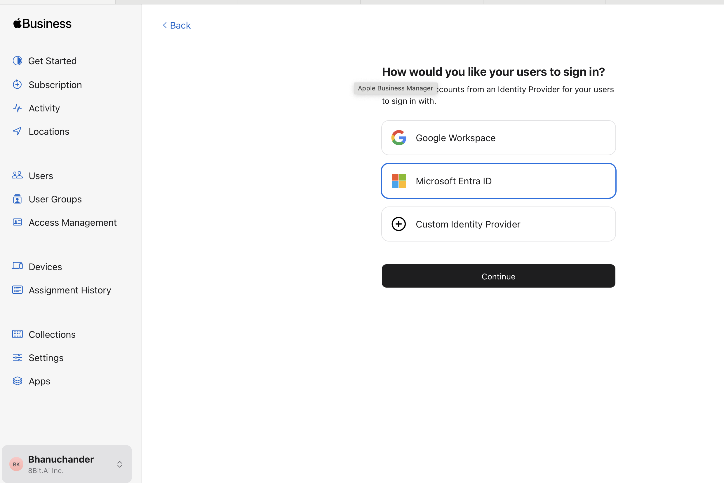

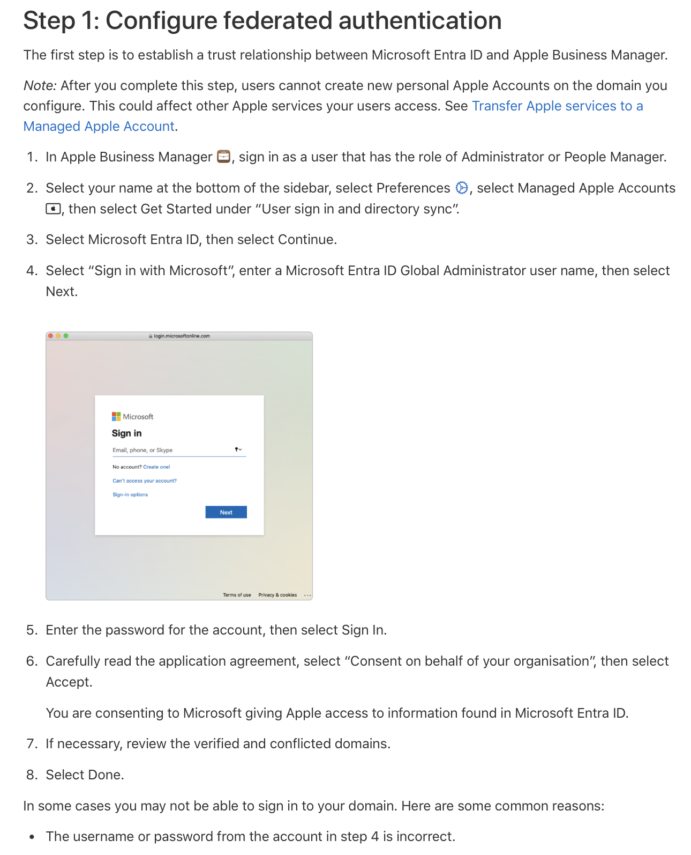
https://support.apple.com/en-in/guide/apple-business-manager/axm8c1cac980/1/web/1

Manually add users in Apple Business Manager
https://support.apple.com/en-in/guide/apple-business-manager/axme2e2158c6/web

Add user groups in Apple Business Manager

https://support.apple.com/en-in/guide/apple-business-manager/axm5e47e90df/web

Edit a role’s privileges

https://support.apple.com/en-in/guide/apple-business-manager/axm97dd59159/web

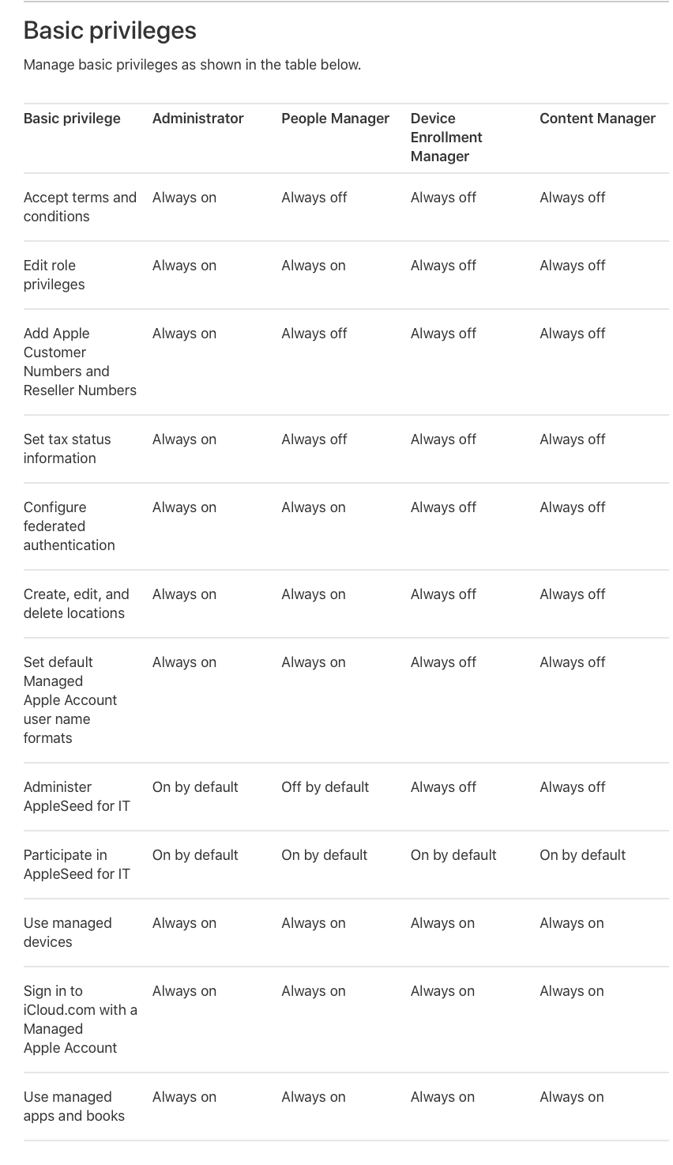

Intro to deploying packages in Apple Business Essentials

https://support.apple.com/en-in/guide/apple-business-essentials/axmeeed343b0/web

Enrolling devices

https://support.apple.com/en-in/guide/apple-business-essentials/axm8ffbc304f/1.0/web/1.0

https://support.apple.com/en-in/guide/apple-business-manager/axm6a88f692e/web

Device workflow in Apple Business Manager
Apple Business Manager provides a fast, streamlined way for you to deploy Apple devices that your organisation has purchased directly from Apple, a participating Apple Authorised Reseller, or an authorised mobile network provider. You can automatically enrol devices in mobile device management (MDM) without having to physically touch or prep the devices before users get them.
After you sign up for Apple Business Manager, you have five steps to complete before you can start managing devices.

Step 1: Link to Apple or to a participating reseller
If you link your Apple Customer Number or Reseller Number to Apple Business Manager, after the linking is complete, any orders of the following devices appear automatically in Apple Business Manager: iPhone, iPad, Mac, Apple TV, Apple Watch, Apple Vision Pro. See Manage device suppliers.

Step 2: Link to a third-party MDM solution
You must link to at least one third-party mobile device management (MDM) solution in Apple Business Manager before you can begin assigning devices.
https://www.youtube.com/watch?v=uD810_h2UXQ

https://learn.microsoft.com/en-us/mem/intune/enrollment/tutorial-use-device-enrollment-program-enroll-ios

Step 3: Add your devices to Apple Business Manager
Devices purchased with your Apple Customer Number or Reseller Number appear automatically in Apple Business Manager. You can also manually add devices you own, using Apple Configurator. See Add devices from Apple Configurator.

Step 4: Assign a device to an MDM server
After a device appears in Apple Business Manager, you must assign it to an MDM server. You can manually assign a device to an MDM server or set up automatic assignment. See Assign, reassign or unassign devices.

Step 5: Enrol a device in MDM
Devices can now be enrolled in MDM, so that management policies can be applied. You can automatically enrol devices you own, or users can enrol their devices manually. When users enrol their device, that device is assigned to MDM and added to the device list in Apple Business Manager.

